BALTIMORE CITY BOARD OF ETHICS
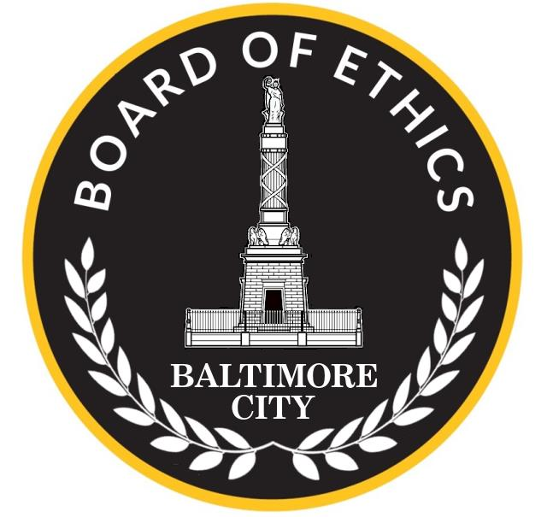
COMPLAINT FORM

The Baltimore City Board of Ethics is an independent body that oversees and enforces the Public Ethics Law, contained in Article 8 of the City Code. The Ethics Law applies to all Baltimore City officials, employees, and lobbyists. It ensures that City officials and employees serve the public with fairness and impartiality by prohibiting them from using their official duties for private gain. It also requires City officials and many other City employees to publicly disclose their private financial interests and other kinds of interests, and it requires lobbyists to register and disclose information about their activities.

You may file a complaint with the Ethics Board if you suspect a violation of the Ethics Law. Although you must sign your complaint, your identity and contact information will be kept confidential, as required by the Ethics Law. After receiving a complaint, Ethics Board staff may contact you for additional information. Staff will undertake a preliminary investigation and will inform you of the outcome at the conclusion of the process.

Section I - Complainant Information
*Your name and contact information will remain confidential. Please fill in at least one of the contact fields below so Ethics Board staff can contact you for further information, if necessary, and to update you on the outcome of the case.
First Name: ________________________ Last Name: ____________________________________

Address: __________________________________________________________________
City: _____________________ State: ____________________ Zip Code: _________________

Phone Number: ________________________________________________

Email Address: ________________________________________________

Section II - Case Information
Please provide all available information about the person(s) or entity(s) you believe potentially violated the Ethics Law. Attach additional pages if there are multiple people or entities involved in the violation.

This person is a: ____Baltimore City Official or Employee _____Baltimore City Contractor or Vendor

____Lobbyist ____Private Business Entity _____Non-profit Organization

____Other (explain: ____________________________________)

Person’s or Entity’s Name: _______________________________________________________________

Person’s Position with City (if applicable): __________________________________________

Name of Business/Organization (if applicable):_________________________________________

Address (if known): __________________________________________________________________
City: ___________________ State: ________________ Zip Code:_______________

Phone Number (if known): ________________________________________________

Email Address (if known): ________________________________________________
What category (or categories) best describes the Ethics Law violation you are reporting?

___ Conflict of Interest (an official/employee takes actions in their City job that might benefit them or a family member personally and/or might benefit their property or an entity with which they or a family member are affiliated)

___ Improper Gift (an official/employee solicits and/or receives – for themself or someone else – money, goods, or services from a person, business, or organization that does business with the City or wants to do business with the City)

___ Improper Outside Employment (a current or former official/employee has another job that might benefit from actions they take—or took—while working for the City)

___ Improper Use of Official Position (an official/employee uses their position with the City in a way that benefits them or someone else personally)

___ Improper Financial Disclosure (an official/employee fails to disclose any or all of the information required in their financial disclosure statements, such as their properties, business affiliations, and other sources of income)

___ Lobbying Violation (a person, business, or organization is trying to influence City legislation or policy but they aren’t registered with the Ethics Board and/or are engaging in other improper lobbying behavior)

___ Improper Use of Confidential Information

___ Other (explain: )

Below, please explain the facts you believe to be a violation of the Ethics Law. The more details you provide, the better we may investigate your complaint. For example, tell us the person(s) or entity(s) involved, the relevant time period(s), the allegedly improper actions, and how or why you believe this is a violation. Attach additional pages or documents if necessary.

Section III - Witness Information

Are there other individuals who witnessed or know about the potential violation you are reporting?
____ YES ____ NO UNSURE

If yes, please give us contact information for your witnesses (attach additional pages if there are multiple witnesses).
First Name: ________________________ Last Name: ____________________________________

Address (if known): __________________________________________________________________
City: _____________________ State: ___________________ Zip Code: ________________

Phone Number (if known): ________________________________________________

Email Address (if known): ________________________________________________
Below, please explain how this person witnessed or knows about the potential violation you are reporting.

Section IV - Verification

I, _______________________________________, SOLEMNLY AFFIRM UNDER PENALTIES OF PERJURY THAT THE CONTENTS OF THIS COMPLAINT FORM AND OF ANY ACCOMPANYING INFORMATION ARE TRUE TO THE BEST OF MY KNOWLEDGE, INFORMATION, AND BELIEF.

Signature: __________________________________________
Date: _____________________

